**Data Science & Machine Learning: Lab Cycle 3**

**Mathplotlib**

**Demonstrate creating various types of charts and plots using functions in mathplotlib library**

1. Sarah bought a new car in 2001 for $24,000. The dollar value of her car changed each year as shown in the table below.

**Value of Sarah's Car**

**Year Value**

**2001 $24,000**

**2002 $22,500**

**2003 $19,700**

**2004 $17,500**

**2005 $14,500**

**2006 $10,000**

**2007 $ 5,800**

Represent the following information using a line graph with following style properties

* **X- axis - Year**

**Y –axis - Car Value**

* **title –Value Depreciation (left Aligned)**
* **Line Style dashdot and Line-color should be red**
* **point using * symbol with green color and size 20**

Subplot() provides multiple plots in one figure.

1. Following table gives the daily sales of the following items in a shop

|  |  |  |  |  |  |
| --- | --- | --- | --- | --- | --- |
| Day | Mon | Tues | Wed | Thurs | Fri |
| Drinks | 300 | 450 | 150 | 400 | 650 |
| Food | 400 | 500 | 350 | 300 | 500 |

Use subplot function to draw the line graphs with **grids(color as blue** and line style dotted) for the above information as 2 separate graphs in two rows

1. Properties for the Graph 1:

* X label- Days of week
* Y label-Sale of Drinks
* Title-Sales Data1 (right aligned)
* Line –dotted with cyan color
* Points- hexagon shape with color magenta and outline black

1. Properties for the Graph 2:

* X label- Days of Week
* Y label-Sale of Food
* Title-Sales Data2 ( center aligned)
* Line –dashed with yellow color
* Points- diamond shape with color green and outline red

1. Create scatter plot for the below data:(use Scatter function)

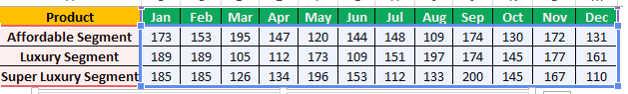

Create scatter plot for each Segment with following properties within one graph

* X Label- Months of Year with font size 18
* Y-Label- Sales of Segments
* Title –Sales Data
* Color for Affordable segment- pink
* Color for Luxury Segment- Yellow
* Color for Super luxury segment-blue

1. Display the above data using multiline plot( 3 different lines in same graph)

* Display the description of the graph in upper right corner(**use legend())**
* Use different colors and line styles for 3 different lines

1. 100 students were asked what their primary mode of transport for getting to school was. The results of this survey are recorded in the table below. Construct a bar graph representing this information.

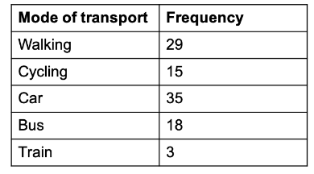

Create a bar graph with

* X axis -mode of Transport and Y axis ‘frequency’
* Provide appropriate labels and title
* Width .1, color green

1. We are provided with the height of 30 cherry trees.

The height of the trees (in inches): 61, 63, 64, 66, 68, 69, 71, 71.5, 72, 72.5, 73, 73.5, 74, 74.5, 76, 76.2, 76.5, 77, 77.5, 78, 78.5, 79, 79.2, 80, 81, 82, 83, 84, 85, 87.Create a histogram with a bin size of 5